INDIAN SCHOOL AL WADI AL KABIR
UNIT TEST (2022 - 23)
Class: XII Sub: BIOLOGY (044) Max Marks: 30
Date: 26.05.2022 Set - 1 Time : 1 hour

GENERAL INSTRUCTION:
- This question paper consists of four sections A, B, C & D. Section A contains 6 questions of one mark each, Section B is of 5 questions of two marks each, Section C is of 3 questions of three marks each and section D is 1 question of five marks each.
- All questions are compulsory.
- There is no overall choice. However, an internal choice has been provided in one question of 2 marks, in one question of 3 marks and 1 question of 5 marks weightage. Attempt only one of the alternatives in such questions.
- Wherever necessary, the diagrams drawn should be neat and properly labelled.
SECTION A (6 X 1 = 6)
1.“Cleistogamous flowers are invariably autogamous because”
(a) These flowers do not open at all.
(b) There is no chance of cross – pollen landing on the stigma.
(c) These flowers have exposed anthers and stigma.
(d) These flowers are wind pollinated.
2. A particular species of plant produces light, non-sticky pollen in large numbers and its
stigmas are long and feathery. These modifications facilitate pollination by:
- Insects
- Water
- Wind
- Animals.
3.Spermiation is the process of the release of sperms from:
- Seminiferous tubules
- Vas deferens
- Epididymis
- Prostate gland

4.Which of the following hormones is not secreted by human placenta?
  - HCG
  - Estrogen
  - Progesterone
  - LH
5. Assertion: Hybrid seeds have to be produced every year
Reason: If seeds from hybrids are sown the plants in the progeny will maintain hybrid
characters
- Both assertion and reason are true, and the reason is the correct explanation of the assertion.
- Both assertion and reason are true, but the reason is not the correct explanation of the assertion.
- Assertion is true but reason is false.

d. Both assertion and reason are false
6. Assertion: Human skin colour is an classic example of Polygenic inheritance
Reason: In a polygenic trait the phenotype reflects the contribution of each allele and the
effect of each allele is additive.
- Both assertion and reason are true, and the reason is the correct explanation of the assertion.
- Both assertion and reason are true, but the reason is not the correct explanation of the assertion.
- Assertion is true but reason is false.

d. Both assertion and reason are false
SECTION B (5 x 2 = 10)
7. T.S. of anther shows four layers
(i) Name and State the function of the innermost layer.
(ii) How many male gametes and female gametes are produced by:
a) 5 microspore mother cells b) 5 megaspore mother cells
8. a. Identify the stage of the embryo development from the given figure
b. Draw and name the stage of the embryo development before and after this stage.
9. Given below is the Blastocyst stage of the human embryo, answer the questions in relation to it.
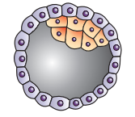 X
Y
Label the parts X and Y and also state their functions.
10.Describe the process of how the Graafian follicle is formed from the secondary follicle.
11.What pleiotropic inheritance, explain with an example.
OR
Explain the phenomenon of linkage and recombination.
SECTION C (3 x 3 = 9)
12.Represent Schematically the hormonal regulation of spermatogenesis in humans
OR
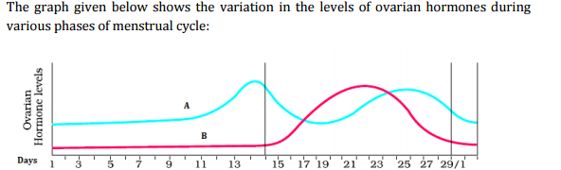
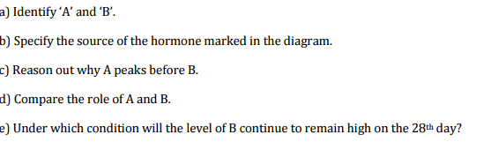
13. a) Some plants such as Viola produce two types of flowers, what advantage does
the plant get due to it.

b) Geitonogamy is genetically similar to autogamy- give reason
c) A typical angiosperm embryo sac, at maturity, though 8-nucleate is 7-celled- comment

14.Draw a neat and labelled diagram showing a diagrammatic view of a typical anatropous ovule.
SECTION D - Case study (1 x 5 = 5)
The genotypic ratios of Mendel’s cross can be calculated using mathematical probability, by simply looking at the phenotype of a dominant trait. However, it is not possible to know the genotypic composition. That is, for example, whether a tall plant from F1 or F2 has TT or Tt composition, cannot be predicted. Mendel carried out a test cross to predict the genotype of the test organism.
15.a) Design Mendel’s test cross where violet colour flower is dominant over white colour flower to determine the genotype of the test organism.
b) Explain briefly the concept of dominance.
OR
ABO blood groups are controlled by the gene I. The plasma membrane of the red blood cells has sugar polymers that protrude from its surface and the kind of sugar is controlled by the gene(I). The gene (I) has three alleles, because humans are diploid organisms, each person possesses any two of the three I gene alleles. Since there are three different alleles, there are six different combinations of these three alleles that are possible, and therefore, a total of six different genotypes of the human ABO blood types
a) Identify the six different combinations and the blood group they represent, also state the type of dominance shown by the alleles with reasons.
b) A child has blood group O. If the father has blood group B and mother blood group A, work out the genotypes of the parents and the possible genotypes of the other offspring.

